The following cards are designed for combat within a theoretical field of 100 yards each way.

Unit Name: 3rd Spartan Hoplite Regiment
Unit Type: Spartan Hoplite

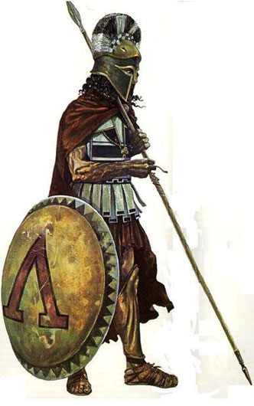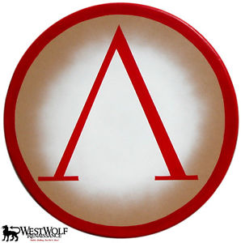
Image Credit: http://www.ancientmilitary.com/spartan-weapons.htm and http://www.ebay.com/itm/Classic-Round-GREEK-LAMBDA-SHIELD-sca-larp-spartan-trojan-troy-300-armor-/150896846615

Description:
Attack: +2 to hit.
Damage: d4
HitPoints: 3
Unit Size: 50
Armor Class: 10
Defense: +5
Speed: 10 squares
Special Ability: Phalanax Formation: The hoplites for a deep line using their shields and spears as cover. This virtually impenetrable defensive maneuver was a one of the most powerful of the ancient world. [Toggling the Phalanax Formation doubles the defense bonus, but reduces their speed by half.)

Unit Name: Persian Immortals
Unit Type: Persian Heavy Infantry
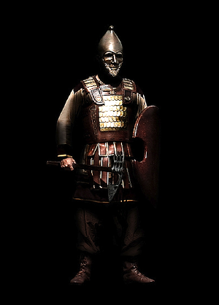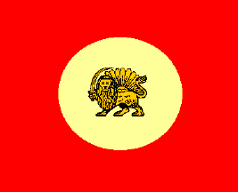
Image Source: http://www.cais-soas.com/CAIS/History/hakhamaneshian/AchaemenidMilitaryEquip.htm and http://flagspot.net/flags/ir-pers.html

Description: Heavy infantry, that were kept constantly at a strength of exactly 10,000 men. A feared force on the battlefield they participated in the Battle of Thermopylae(the historical basis for the movie 300).
Attack: +5 to hit.
Damage: d6
HitPoints: 2
Unit Size: 100
Armor Class: 7
Defense: +3
Charge Bonus: +5
Speed: 13 squares
Special Ability: Berserk Charge Formation: Persian immortals crash into the enemies line, each attacking twice but sustaining a -2 bonus to their defense. [Toggling the Berserk Charge Formation gives each unit the chance to attack twice but lowers their defense by 2 before the next turn.)

Sample Combat:

1 unit of Spartan Hoplites vs 1 unit of Persian Immortals. Each spaced 100 yards apart. [Each square equals 5 yards]

Move 1 - Spartans: The hoplites advance 10 squares, so that they are now only 50 yards away from the Persians. They than toggle defense, adding +5 to their defense.

Move 1 – Persians: The Persian's advance 10 yards as well, bringing them face to face with the Spartans. They attack!
Swinging their swords, each of the 100 units attack! Of this attack, 28 of them hit. Those who hit, do 1,3, 4, 1, 2, 2, 1, 1, 3, 4, 2, 3, 1, 2, 4, 3, 1, 1, 1, 4, 3, 2, 2, 1, 4, 1, 2, 1,
This causes 10 Spartan hoplites to die and seriously wounds the other of the 28. This leaves 22 unwounded hoplites and 18 injured ones.

Move 2 – Spartans: Switching into phalanax formation, the hoplites double their defense and attack the

